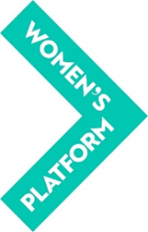

NOMINATION FORM – MEMBER OF COMMITTEE

(Name of Member Organisation) ___________________________________

(Address) _____________________________________________________

HEREBY NOMINATES

(Name in Capitals) ______________________________________________

to serve as a Member of the Women’s Platform Committee for the period 2023-25

The Declaration and Consent Form, completed by the above named nominee, is attached to this Nomination Form.

I _________________________________ (Name in Capitals)

Being the Authorised Representative of the above Member organisation, certify this nomination on behalf of the organisation.

Signature _______________________

Date _______________________

N.B. The person nominated may be any woman over 16 but must be nominated by a Full Member organisation in Northern Ireland

N.B An electronic signature is accepted

